1. Create a database “Student” with the following attributes Rollno,

Age, ContactNo, Email-Id.

db.createCollection("Student");

show dbs

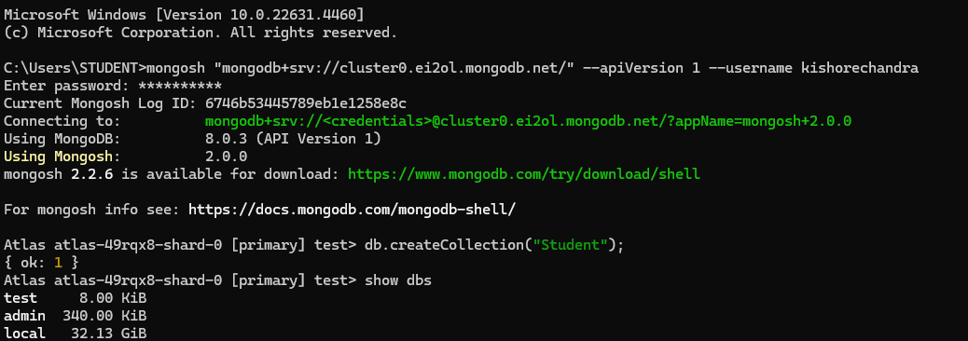

2. Insert appropriate values

db.Student.insert({RollNo:1,Age:21,Cont:9876,email:"antara.de9@gmail.com"});

db.Student.insert({RollNo:2,Age:22,Cont:9976,email:"anushka.de9@gmail.com"});

db.Student.insert({RollNo:3,Age:21,Cont:5576,email:"anubhav.de9@gmail.com"});

db.Student.insert({RollNo:4,Age:20,Cont:4476,email:"pani.de9@gmail.com"});

db.Student.insert({RollNo:10,Age:23,Cont:2276,email:"rekha.de9@gmail.com"});

db.Student.find()

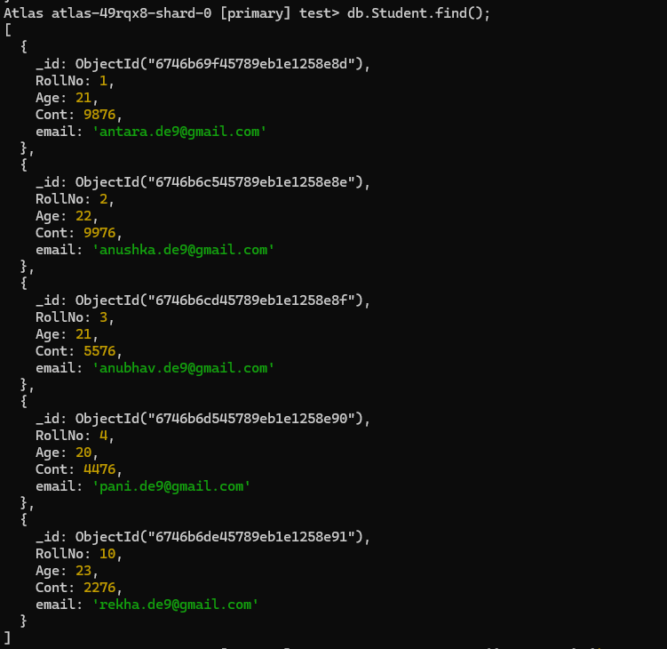

3. Write query to update Email-Id of a student with rollno 10.

db.Student.update({RollNo:10},{$set:{email:"Abhinav@gmail.com"}})

4. Replace the student name from “ABC” to “FEM” of rollno 11.

db.Student.update({RollNo:11,Name:"ABC"},{$set:{Name:"FEM"}});

db.Student.find();

